Question 1:
[org 0x0100]
num1: dw 0
mov
jmp start

start:
mov al, 10110010b
rol al,4
mov ah, 01011101b
rol ah,4

mov word [num1],ax

mov ax,0x4c00
int 21h

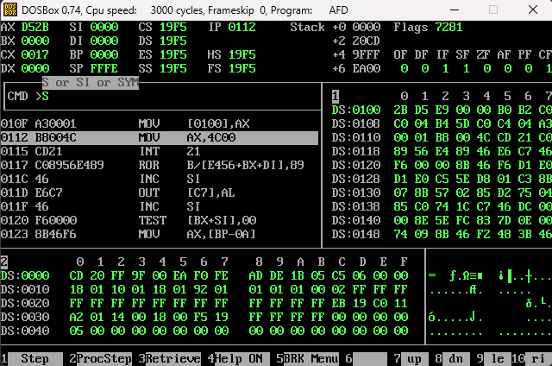

Question 2:
[org 0x0100]
num : dw 0
jmp start

start:
mov ax, 1011001001011101b
mov bx,ax

shl bx,1
shr ax,1

and ax, 0x5555
and bx, 0xAAAA

or ax,bx

mov [num],ax

mov ax, 0x4c00
int 21h

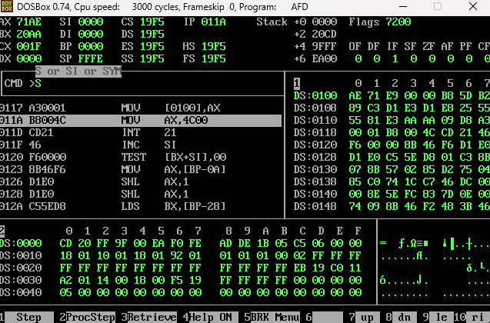

Question 3 :
[org 0x0100]

mov ax, 101011111b
mov dx,0
mov cx,16

jmp start

start:
shr ax,1
jc increment
jnc decrement

increment:
inc dx
dec cx
cmp cx,0
jnz start
jz set

decrement:
dec cx
cmp cx,1
jnz start
jz set

set:
cmp dx,1
jz exit
mov ax,dx
inc bx
mov cx,16
mov dx,0
jmp start

exit:
inc bx
mov ax,0x4c00
int 21h

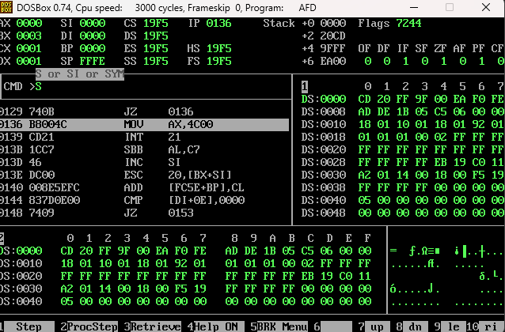

Question 4:
[org 0x0100]
jmp start

addition:
push bp
mov bp,sp
mov ax,[bp + 6]
add ax, [bp+4]
pop bx
ret

start:
mov ax,8
push ax
mov ax, 2
push ax
call addition

mov ax,0x4c00
int 21h
